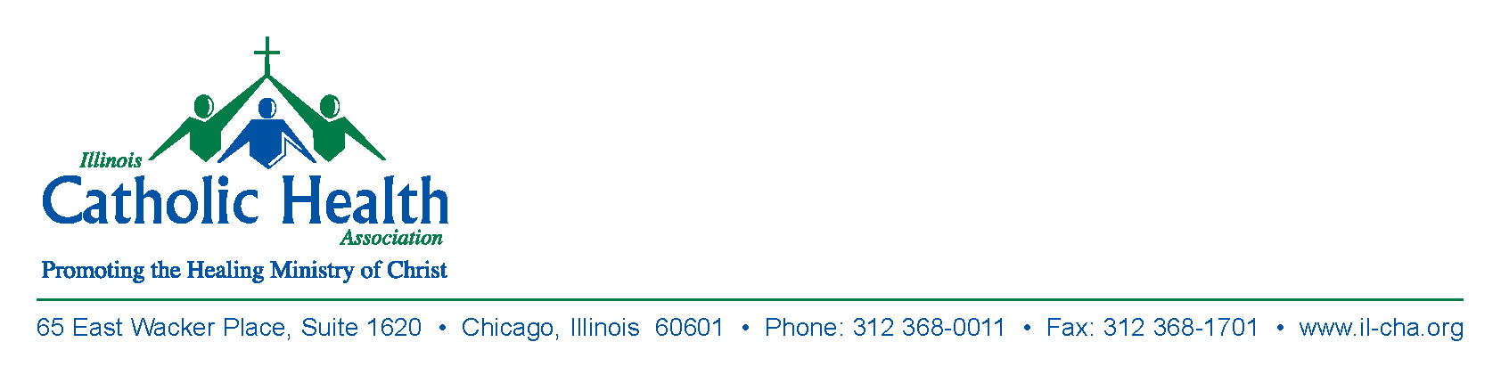

ICHA PHYSICIAN RETREAT REGISTRATION FORM

Day and Date: Friday, October 27, 2017

Time and Location: 9:00AM Mass (Optional)
Saint Francis Chapel
530 NE Glen Oak Avenue
Peoria, IL 61603

Meeting 10:00AM – 2:00PM
Jump Education Center
1306 N. Berkley Avenue
Peoria, IL 61603

Name Organization

_________________________________ __________________________________

Email address __________________________________
Email address required for CME credits.

Please list any dietary restrictions:

____________________________________________________________________

____________________________________________________________________

A donation of $100.00 per person is requested to cover the cost of food, speakers, and meeting space. We do not accept credit cards. Please make the check payable to ICHA. Thank you.

Mail with Check to: Illinois Catholic Health Association
65 East Wacker Place, Suite 1620
Chicago, IL 60601
Tel: 312 368-0011
Email: mjoachim@il-cha.org

