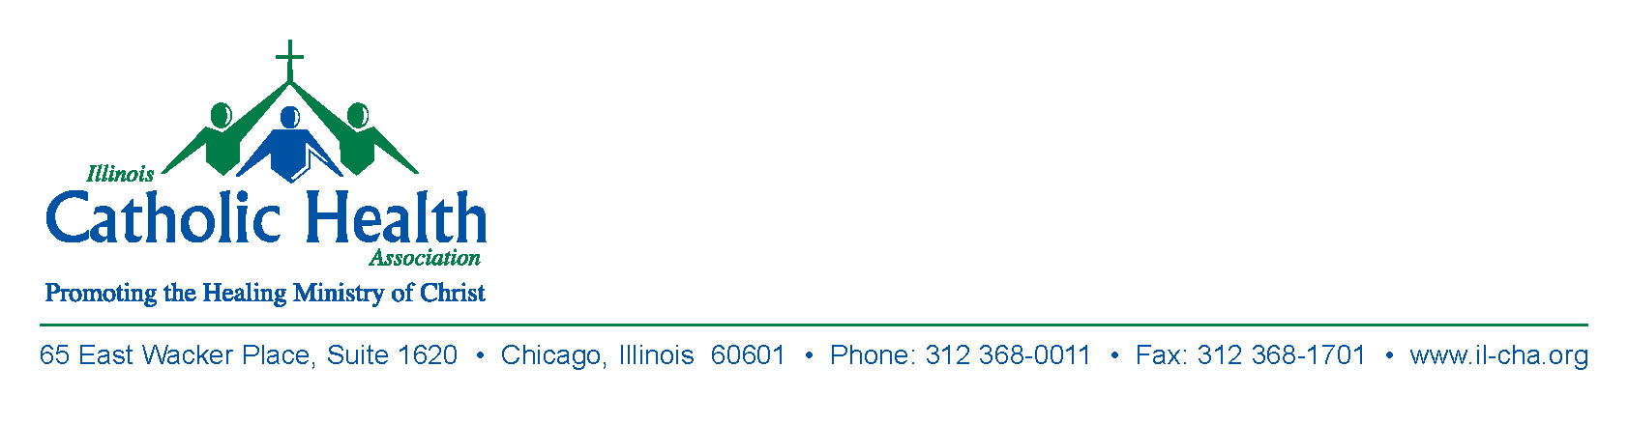
Illinois Catholic Health Association
Physician’s Retreat
Jump Education Center
1306 N. Berkeley Avenue
Peoria, Illinois
Friday, October 27, 2017

AGENDA

9:00AM Mass (Optional)
Saint Francis Chapel
530 NE Glen Oak Avenue
Peoria, Illinois

10:00AM Welcome and Opening Prayer
Msgr. Mark Merdian
ICHA Board Chair
Healthcare Vicar, Peoria Diocese

10:30AM Caring for the Soul of Physicians
(First Session)
Myles N. Sheehan, SJ, MD

11:15AM Table Discussions

Noon Lunch

12:45PM Healing the Healer
(Second Session)
Myles N. Sheehan, SJ, MD

1:30PM Closing Prayer
Msgr. Mark Merdian

2:00PM Adjournment

