**Sample Bulletin Announcements**

***(Bulletin Announcement #1*) Two weeks prior to Appeal Sunday (sample layout):**

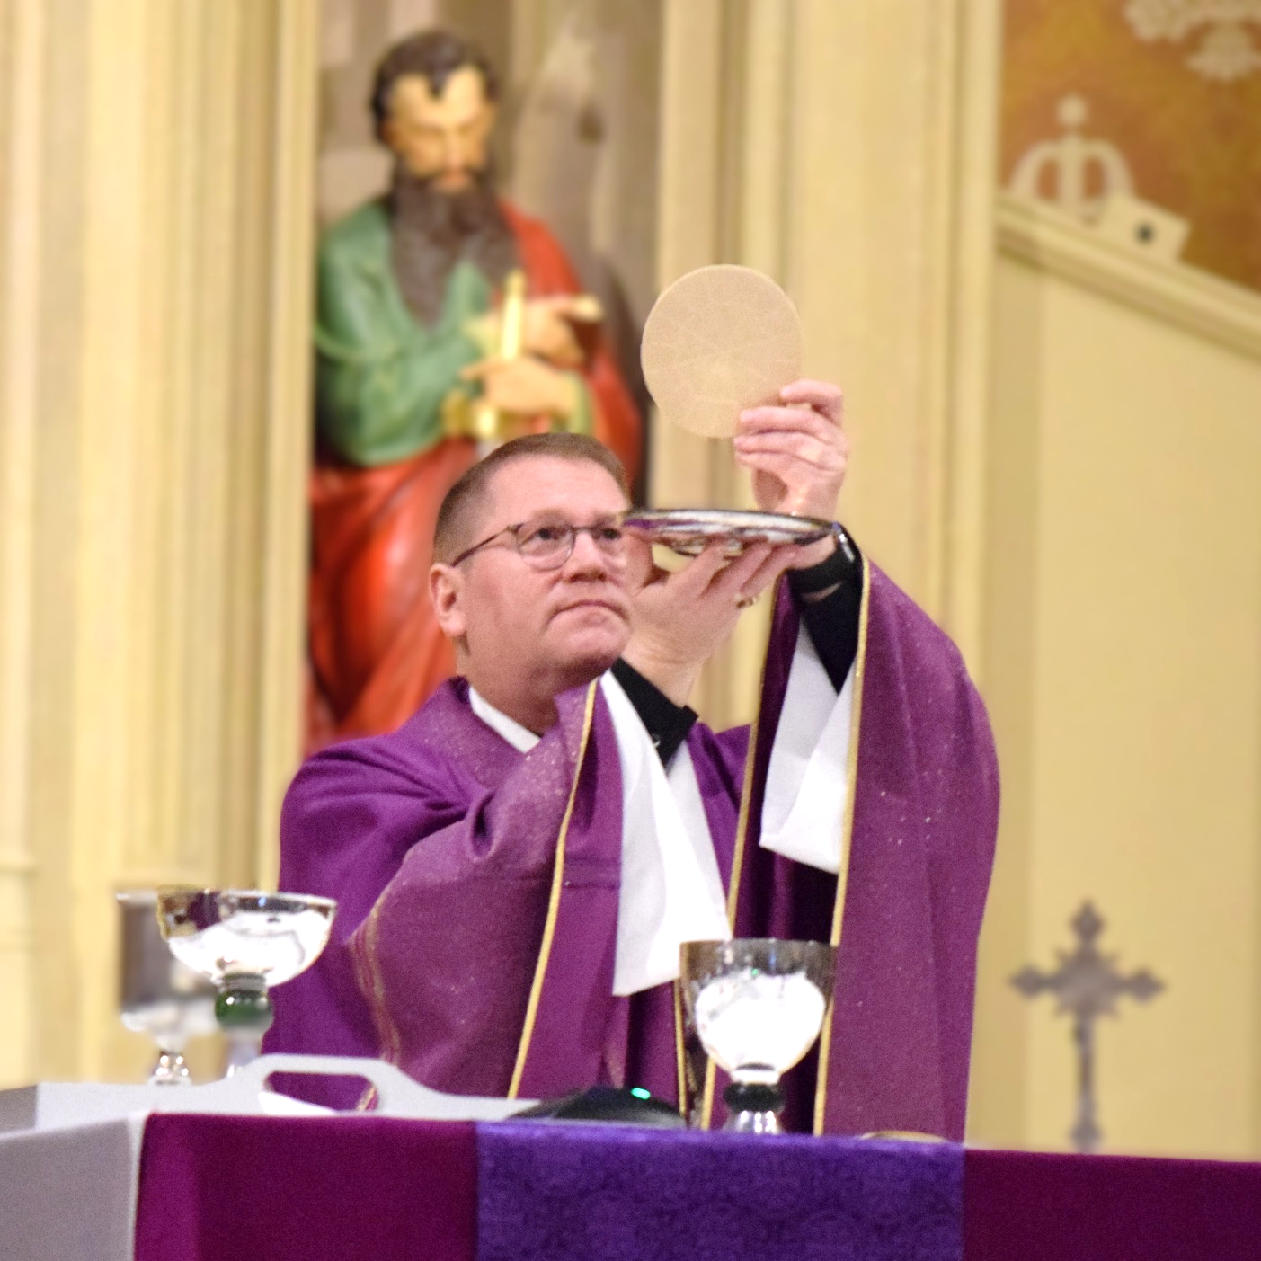

**2024 Annual Diocesan Appeal**

**September 7-8, 2024**

Glory of God.”

“Do everything for the

In two weeks, our parish will be participating in the Annual Diocesan Appeal (ADA) for the Diocese of Peoria. We are encouraged by St. Paul to”do everything for the glory of God. The Annual Diocesan Appeal gives us an opportunity to respond by sharing our gifts which will enable and equipp the Church for today’s opportunities and challenges in witnessing to our faith . There are many ministries and apostolates that the Diocese can offer that we as a single parish cannot. Recruitment and training of priests, vocation discernment program for young men, marriage preparation, ministry to our students on college campuses, evangelization, Catholic Charities programs… these are just a few of the many services we receive from the Diocese of Peoria. Your support, in prayer and through your sacrificial gift to the Annual Diocesan Appeal, makes it possible to provide these services.

**Please prayerfully consider making a pledge to this year’s appeal.**

***(Bulletin Announcement #2*)**

**One week Prior to Appeal Sunday**: Next weekend, September 7-8, we will begin our Annual Diocesan Appeal, which is an opportunity to help the Catholic Diocese of Peoria raise necessary funds for many ministries and apostolates that we as a single parish cannot offer. **This week, parishioners throughout the Diocese will receive a mailing asking for a pledge to support the Appeal. The mailing will include a pledge card and a return envelope addressed directly to the Diocese. You can make a one time gift or make a pledge over eight month.** We will also have pledge cards available in the pews next weekend. Thank you for your continuing support of our parish, diocese, and the work of the Church throughout the world.

***(Bulletin Announcement #3*)**

**Appeal Sunday:** Today, the 2024 Annual Diocesan Appeal begins in our parish and throughout the Diocese of Peoria. Through the ADA we are able to advance the mission entrusted to us by the Lord. In our parishes, our schools, our Newman Centers on college campuses, in our social service ministries in Catholic Charities we create places of encounter with Jesus. And we know that when we encounter Jesus, lives are changed.

If you have not made your pledge by mail, please fill out the pledge card in your pew. **The goal for our parish is ______________** and we can reach it only with your help.

Contributions can be made by check payable to the Catholic Diocese of Peoria, by a credit or debit card, by direct debit from checking or savings account or online at www.cdop.org/ada. Gifts of appreciated stock, grain, qualified charitable distributions (QCDs) or donor advised funds have special considerations and requirements. Contact 309-671-1550 for more information.

***(Bulletin Announcement #4*)**

**Follow Up Sunday:** The 2024 Annual Diocesan Appeal is now underway in our parish. Thank you to all who have already pledged to the appeal. Your gift supports ministries that help form our young people into disciples eager to share their faith with others. No gift is too small, and our parish is trying to reach 100% participation. If you have not given yet, please consider filling out a pledge card today and mail it to the Diocese or drop it in the collection basket. Addition pledge cards are in the narthex/pews. Every dollar raised over our goal will be returned to our parish to help us______________________.

***(Bulletin Announcement #5*)**

**After receiving the first ADA report:** Thank you to all who made a pledge to the Annual Diocesan Appeal. To date, we have received ___ gifts/pledges totaling $______ towards our goal of $______. Your generosity helps give food to the hungry, training to our seminarians, prepare engaged couples for the sacrament of marriage, give support to parishes and leadership in our schools. If you have not completed a pledge card, please do so. There are envelopes in the vestibule / pews. Every dollar raised to make our goal supports important diocesan ministries, and every dollar raised over our goal will be kept in the parish to help us_________________. To those who have pledged, thank you!

**Following weeks:**

Have you made a pledge for the 2024 Annual Diocesan Appeal? There is still time. A gift to the ADA, large or small, can go a long way. Consider a one-time gift or a monthly pledge for eight months. There are envelopes in the vestibule / pews. Every dollar raised to make our goal supports important diocesan ministries, and every dollar raised over our goal will be kept in the parish to help us ________. To date, we have received ___ gifts/pledges totaling $______ towards our goal of $______. To those who have pledged, thank you!

Or:

Thanks to the generosity of ___ parish families, we are well on our way towards our goal of $______.  Each gift is important to the mission of the diocese.  If you have not yet had the opportunity, please return a pledge card with your response today.  There are cards on the tables in the back of church. Your gift helps support the central ministries of our diocese including religious education of our young people, faith formation of adults, training of our future priests, Newman Centers on our college campuses and much more. Every dollar raised over our goal will be kept in the parish to help us_______. To those who have contributed, we are most grateful.